Assignment No. 14
- TITLE : Create a Java program to implement a Student Grading System that accepts student details such as Name, Roll No, Marks of 5 subjects, Calculates total, percentage, and grade, displays results in a tabular format. Use inheritance to separate basic student info from academic performance.

- CODE:
package prac14;
import java.util.*;

class Student {
String name;
int rollNo;

Student(String name, int rollNo) {
this.name = name;
this.rollNo = rollNo;
}
}

class AcademicRecord extends Student {
int[] marks;
int total;
double percentage;
char grade;

AcademicRecord(String name, int rollNo, int[] marks) {
super(name, rollNo);
this.marks = marks;
calculateResults();
}

void calculateResults() {
total = 0;
for (int mark : marks) {
total += mark;
}
percentage = total / 5.0;

if (percentage >= 90) grade = 'A';
else if (percentage >= 80) grade = 'B';
else if (percentage >= 70) grade = 'C';
else if (percentage >= 60) grade = 'D';
else if (percentage >= 40) grade = 'E';
else grade = 'F';
}

void displayResult() {
System.out.printf("%-10d %-15s %-5d %-5d %-5d %-5d %-5d %-5d %-8.2f %-5c\n",
rollNo, name, marks[0], marks[1], marks[2], marks[3], marks[4], total, percentage, grade);
}
}

public class StudentGradingSystem {
public static void main(String[] args) {
Scanner scanner = new Scanner(System.in);

System.out.print("Enter number of students: ");
int n = scanner.nextInt();
scanner.nextLine();

AcademicRecord[] students = new AcademicRecord[n];

for (int i = 0; i < n; i++) {
System.out.println("\nEnter details for Student " + (i + 1) + ":");
System.out.print("Name: ");
String name = scanner.nextLine();
System.out.print("Roll No: ");
int rollNo = scanner.nextInt();

int[] marks = new int[5];
System.out.println("Enter marks for 5 subjects:");
for (int j = 0; j < 5; j++) {
System.out.print("Subject " + (j + 1) + ": ");
marks[j] = scanner.nextInt();
}
scanner.nextLine();

students[i] = new AcademicRecord(name, rollNo, marks);
}

System.out.println("\n\nStudent Results:");
System.out.println("-----------------------------------------------------------------------------");
System.out.printf("%-10s %-15s %-5s %-5s %-5s %-5s %-5s %-5s %-8s %-5s\n",
"Roll No", "Name", "Sub1", "Sub2", "Sub3", "Sub4", "Sub5", "Total", "Percent", "Grade");
System.out.println("-----------------------------------------------------------------------------");

for (AcademicRecord student : students) {
student.displayResult();
}

System.out.println("-----------------------------------------------------------------------------");
scanner.close();
}
}

Output –
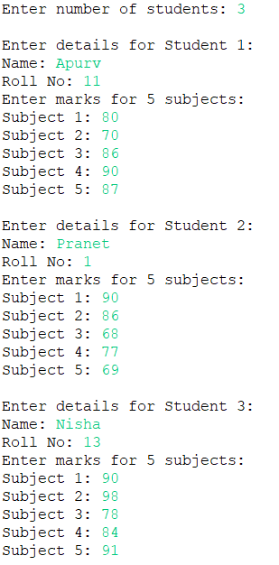
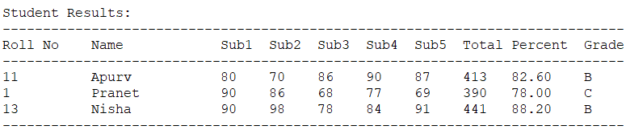

- Conclusion – In this assignment, this Java program successfully demonstrates the use of inheritance by separating basic student information from academic performance calculations. The implementation efficiently handles multiple student records, performs grade calculations, and presents results in a clear tabular format. The object-oriented design with inheritance allows for better code organization and maintainability while providing a functional student grading system.

